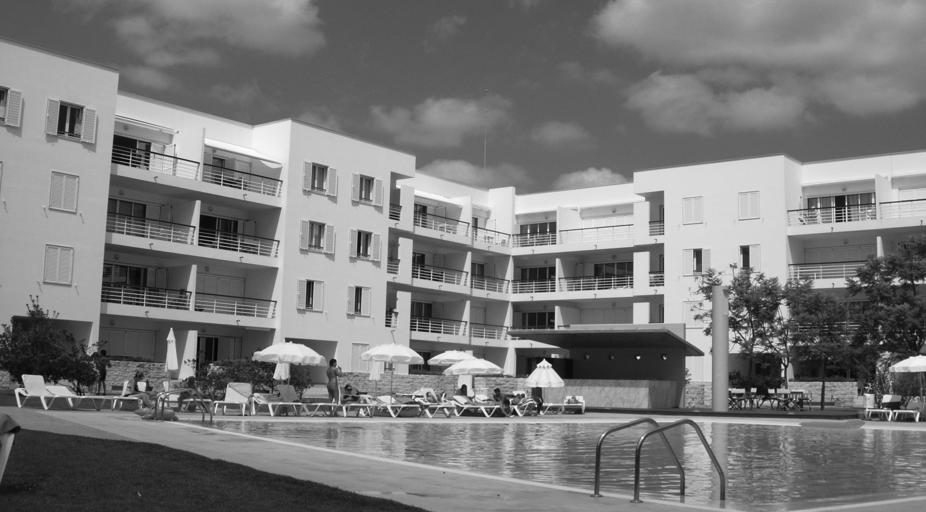
D. Manuel I Bloco B- 2° Fte
Marina de Lagos, Algarve, Portugal

a relaxing, contemporary holiday apartment for rent

CLIENT INFORMATION FORM

Name of client in full
Address
Postcode
Telephone number
Mobile tel number
Other names in full
who are travelling
with you (please
state children’s age)
Email address
Flight Details
Outbound airport of |  | Arrival time |  | Airport of
Departure & flight no. |  |  |  | arrival
Return flight |  | Departure |  | Airport of
number |  | time |  | departure

Date of arrival at apartment
Date of departure
Total number of nights at the apartment
Do you need:
 | Please tick
a cot? |  | *
a high chair? |  | *
a welcome food pack? |  | *

*Prices available on request

Signature |  | Date

Please return form to:
MARIA WYBORN 7 Camden Court, Runcorn, Cheshire UK WA7 6RL
T +44 (0)1928 718551 F +44 (0)1928 791151 E info@mwyborn.co.uk

